**1. Introduction**

This Enterprise Network Project simulates a **scalable and secure university network infrastructure** designed across two campuses separated by 20 miles. Each campus contains multiple departments—Health & Science, Business, Engineering & Computing, and Arts & Design—and requires a flexible architecture capable of supporting both administrative and academic needs.

Key backbone design concepts include:

- **Segmentation using VLANs** for logical separation of departments.

- **RIP v2 for dynamic routing** within the institution’s internal network.

- **Static routes** for carefully controlled access to external resources (such as email or web servers).

- **Router-based DHCP services** to enable automatic IP assignments, reducing manual configuration errors.

This simulated setup provides a learning-oriented blueprint that reflects best practices in real-world enterprise networks while also allowing for future expansion and technological upgrades.

**2. Objectives**

**Network Design and Simulation:** To create a detailed and functional network topology diagram in Cisco Packet Tracer that accurately represents the university's two campuses, buildings, and departments.

**VLAN Implementation:**To configure VLANs on switches to segment the network logically, providing isolation and enhanced security for each department (Health & Science, Business, Engineering & Computing, and Arts & Design).

**RIP v2 Configuration:**To implement RIP v2 as the interior gateway protocol (IGP) for dynamic routing within the internal network, enabling automatic route learning and adaptation to network changes.

**Static Routing Configuration:** To configure static routes to connect the internal network to external networks, such as web servers, email servers, or other external services, providing a controlled and secure path for external communication.

**DHCP Server Configuration:**To configure a router-based DHCP server for Building A to automatically assign IP addresses, subnet masks, default gateways, and DNS server addresses to client devices, simplifying network administration.

**Secure and Reliable Communication:** To ensure seamless and secure communication between departments within each campus and between the two campuses, providing reliable data transfer for both staff and students.

**Documentation:** To create comprehensive documentation outlining the network design, configuration steps, testing procedures, and results.

**3. Scope of the Project**

This project covers the design, implementation, and testing of a complete enterprise-level network setup suitable for a university environment. It provides a **blueprint design** for a realistic academic network, emphasizing scalability, segmentation, and simplified administration. The network is structured to accommodate multiple buildings and campuses, ensuring seamless communication, efficient resource utilization, and future expansion capabilities.

Key components and deliverables include:

* **IP Addressing and Subnetting:** Designing an efficient addressing scheme for all devices, including subnetting for VLANs and buildings, with proper documentation of the rationale behind the plan.
* **Router and Switch Configuration:** Configuring Cisco routers and switches with interface parameters, VLAN assignments, routing protocols, and essential security features.
* **VLAN Segmentation and Inter-VLAN Routing:** Implementing VLANs at the Layer 2 level to separate students, staff, and faculty departments, assigning ports to VLANs, configuring trunk links, and enabling inter-VLAN routing.
* **Routing Protocols:** Deploying RIP v2 for internal dynamic routing (with auto-summary disabled) and static routing for external servers and internet access.
* **DHCP Server Setup:** Configuring DHCP on routers to allocate IP addresses dynamically (initially within Building A), defining pools, excluded addresses, gateways, and DNS servers.
* **Inter-Campus Communication:** Establishing reliable connectivity between university campuses using RIP v2, ensuring direct router-to-router communication.
* **Security Measures:** Applying basic security practices, including VLAN segmentation, router ACLs, and password protection on devices.
* **Scalability and Redundancy:** Ensuring the design supports growth by allowing new departments, buildings, and users to be added with minimal reconfiguration, while also reducing management overhead.

This integrated scope consciously reflects strategies that balance performance, security, and manageability—making the network both **robust for current needs** and **flexible for future institutional expansion**.

**4. Requirements**

**Client:** A large university with two campuses separated by 20 miles.

**Departments:** Four faculties/departments: Health & Science, Business, Engineering & Computing, and Arts & Design.

**Users:** Each staff member has a dedicated PC; students use lab PCs in each department.

**Campus Structure:** The main campus has 3 buildings (A, B, and C) with multiple departments distributed across them. Assume the second campus mirrors this structure, but with fewer departments/buildings (for simplicity).

**Network Segmentation:** Each department must be on a separate VLAN and subnet for security and management.

**DHCP:** Building A must use DHCP for IP address assignment. Buildings B and C might use static addressing or DHCP, depending on the design choices. Justification for the choices is needed.

**Connectivity:** Core network devices (routers, core switches) and some end devices (e.g., servers) require full connectivity to all network segments.

**Switch Configuration:** Switches must be configured with VLANs, trunk ports, access ports, and basic security features (e.g., port security, password protection).

**Internal Routing:** RIP v2 is used for dynamic routing within the internal network. Consider its limitations (hop count).

**External Routing:** Static routing is used to connect to external networks/servers.

**Specific IP Address Ranges:** Assign a specific IP address range (e.g., 192.168.x.0/24) to each VLAN/department. Document the addressing scheme clearly.

**Fault Tolerance (Optional**): Consider implementing redundant links or devices for increased fault tolerance.

**Security (Basic):** Implement basic security measures like limiting SSH access to specific IP addresses or networks on routers and switches.

**5. Network Design**

**Topology:** Create a hierarchical network topology with core switches at the center, distribution switches connecting to the core, and access switches connecting to end devices.

**Building Connectivity:** Buildings A, B, and C are interconnected with core switches using high-speed links (e.g., Gigabit Ethernet).

**VLAN Assignment:** Each department is assigned a unique VLAN ID and subnet. Document the VLAN assignments in a table.

**DHCP Server Location:** A router in Building A acts as the DHCP server for that building's VLANs.

**Routing Protocol:** RIP v2 is configured on all routers for internal routing.

**Static Routes:** Static routes are configured on the main campus router to reach external networks, such as the internet and the second campus. Static routing will also be needed to reach back into the internal network from the outside.

**Inter-VLAN Routing:** Configure inter-VLAN routing on the core switches or routers to allow communication between different VLANs. This will usually be "Router on a Stick" or using a Layer 3 Switch.

**Campus Connection:** The two campuses are connected via a dedicated link (e.g., a leased line simulated by a direct connection in Packet Tracer). Static routes or a tunnel is used for inter-campus communication.

**Diagram:** A detailed network topology diagram is created using Cisco Packet Tracer, showing all devices, connections, VLAN assignments, and IP addressing.

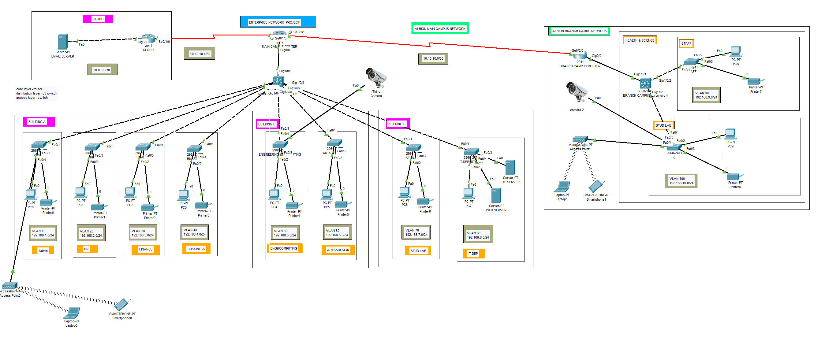

Full Infrasturcture of the Campus Network

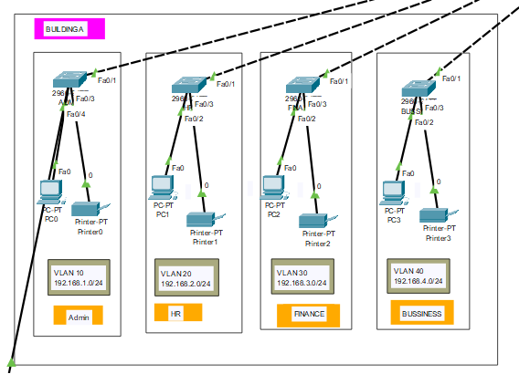

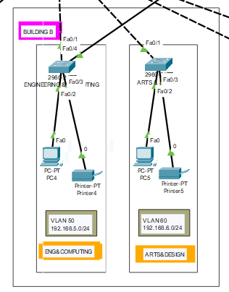

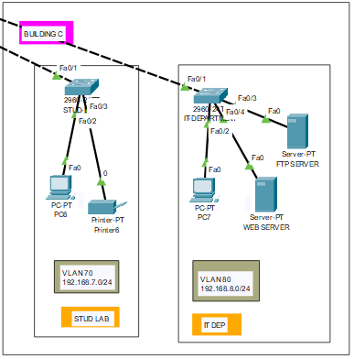

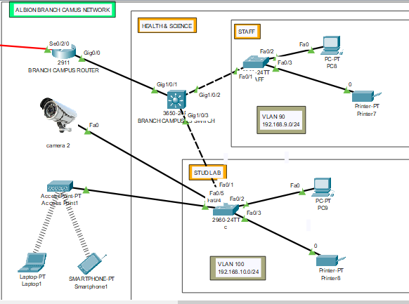

Branch Campus network(Healthcare +staff+Stud lab)

**UML System Diagram:**

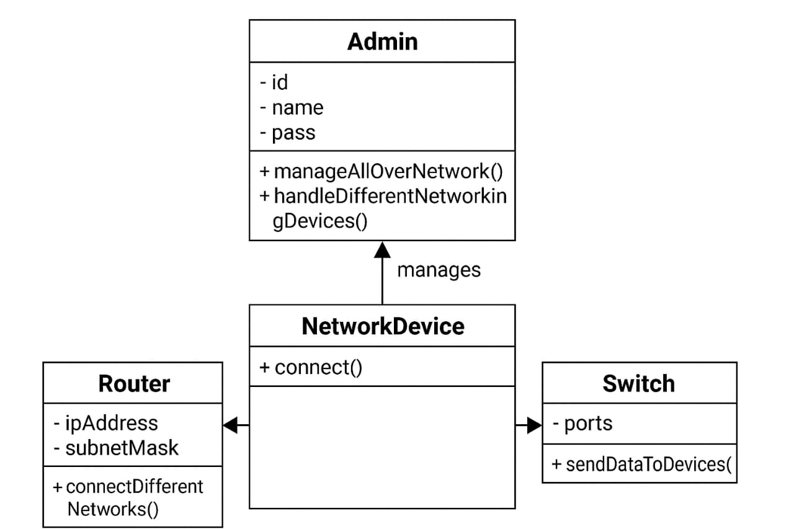

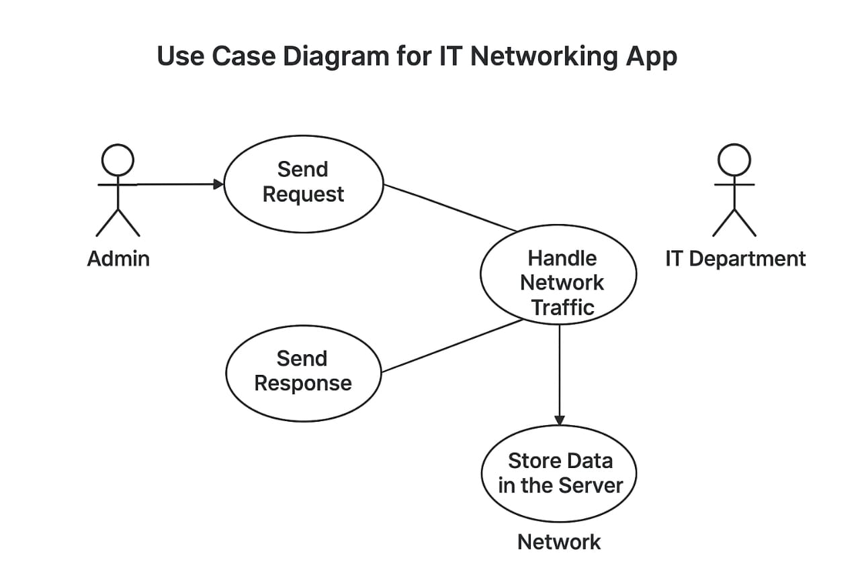

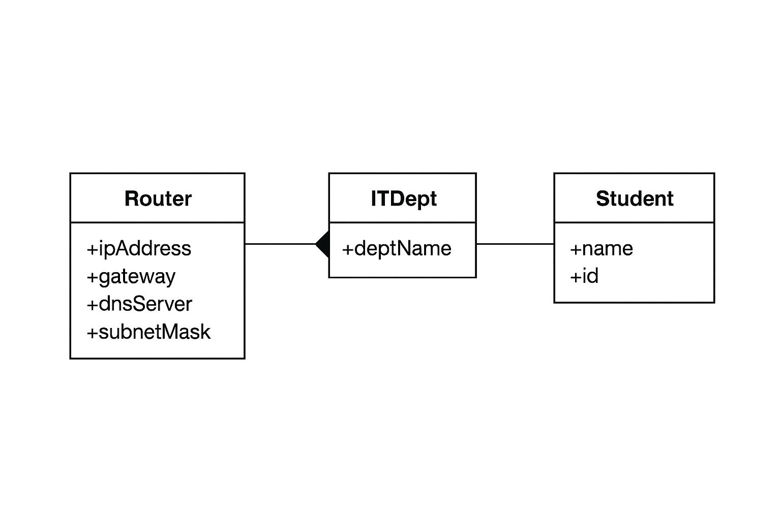

**6. Implementation**

This section provides more granular steps. For each step, justify *why* you are doing it.

For Serieals ports in switch goes in hardware of switch and add hardware part **HWIC-2T**

**Step 1: Turn Interface Up Configuration:**

Router> enable

Router# configure terminal

Router(config)# interface gigabitEthernet 0/0

Router(config-if)# no shutdown

%LINK-5-CHANGED: Interface GigEthernet0/0, changed state to up

%LINEPROTO-5-UPDOWN: Line protocol on Interface GigEthernet0/0, changed state to up

**Add this command all routers to Up**

**Step 2: Set Clockrate Configuration:**

Main_campus_router > enable

Main_campus_router # configure terminal

Main_campus_router (config)# interface serial 0/1/1

Main_campus_router (config-if)# clock rate 64000

Main_campus_router (config-if)# exit

Main_campus_router > enable

Main_campus_router # configure terminal

Main_campus_router (config)# interface serial 0/1/0

Main_campus_router (config-if)# clock rate 64000

Main_campus_router (config-if)# exit

**Step 3: VLAN Configuration**:

On each switch (Access, Distribution, Core,L2 switch):

```cisco

Switch(config)#vlan 10

Switch(config-vlan)#name admin

Switch(config-vlan)#exit

Switch(config)#vlan 20

Switch(config-vlan)#name HR

Switch(config-vlan)#exit

Switch(config)#vlan 30

Switch(config-vlan)#name Finance

Switch(config-vlan)#exit

Switch(config)#vlan 40

Switch(config-vlan)#name bussiness

Switch(config-vlan)#exit

Switch(config)#vlan 50

Switch(config-vlan)#name eng_&_computing

Switch(config-vlan)#exit

Switch(config)#vlan 60

Switch(config-vlan)#name Arts&Design

Switch(config-vlan)#exit

Switch(config)#vlan 70

Switch(config-vlan)#name Stud_lab

Switch(config-vlan)#exit

Switch(config)#vlan 80

Switch(config-vlan)#name IT_DEPT

Switch(config-vlan)#exit

Switch(config)#do wr

Building configuration...

Compressed configuration from 7383 bytes to 3601 bytes[OK]

[OK] ! Repeat for other VLANs as needed

**For assigning interfaces to a VLAN on L2 swicthes:**

Switch(config)# interface range fa0/1 - 24

Switch(config-if-range)# switchport mode access

Switch(config-if-range)# switchport access vlan 10

Switch(config-if-range)# do write

Switch(config-if-range)# exit

Switch(config)# interface range fa0/1 - 24

Switch(config-if-range)# switchport mode access

Switch(config-if-range)# switchport access vlan 20

Switch(config-if-range)# do write

Switch(config-if-range)# exit

Switch(config)# interface range fa0/1 - 24

Switch(config-if-range)# switchport mode access

Switch(config-if-range)# switchport access vlan 30

Switch(config-if-range)# do write

Switch(config-if-range)# exit

Switch(config)# interface range fa0/1 - 24

Switch(config-if-range)# switchport mode access

Switch(config-if-range)# switchport access vlan 40

Switch(config-if-range)# do write

Switch(config-if-range)# exit

Switch(config)# interface range fa0/1 - 24

Switch(config-if-range)# switchport mode access

Switch(config-if-range)# switchport access vlan 50

Switch(config-if-range)# do write

Switch(config-if-range)# exit

Switch(config)# interface range fa0/1 - 24

Switch(config-if-range)# switchport mode access

Switch(config-if-range)# switchport access vlan 60

Switch(config-if-range)# do write

Switch(config-if-range)# exit

Switch(config)# interface range fa0/1 - 24

Switch(config-if-range)# switchport mode access

Switch(config-if-range)# switchport access vlan 70

Switch(config-if-range)# do write

Switch(config-if-range)# exit

Switch(config)# interface range fa0/1 - 24

Switch(config-if-range)# switchport mode access

Switch(config-if-range)# switchport access vlan 80

Switch(config-if-range)# do write

Switch(config-if-range)# exit

**ALBION BRANCH CAMPUS L2 switches**

Switch(config)# interface range fa0/1 - 24

Switch(config-if-range)# switchport mode access

Switch(config-if-range)# switchport access vlan 90

Switch(config-if-range)# do write

Switch(config-if-range)# exit

Switch(config)# interface range fa0/1 - 24

Switch(config-if-range)# switchport mode access

Switch(config-if-range)# switchport access vlan 100

Switch(config-if-range)# do write

Switch(config-if-range)# exit

**Same Commands** **Until the vlan 100 Then We Moves on the layer 3 SWITCH**

**Explanation:**

This configuration assigns multiple FastEthernet interfaces on the Layer 2 switches to different VLANs. The interface range fa0/1 - 24 command is used to select a group of interfaces (from FastEthernet 0/1 to 0/24) at once, allowing bulk configuration of multiple ports. The switchport mode access command sets these interfaces to access mode, which means each port can carry traffic for only a single VLAN. The switchport access vlan command then assigns the selected range of ports to a specific VLAN, such as VLAN 10, VLAN 20, VLAN 30, and so on, depending on the requirement.

Each VLAN represents a separate broadcast domain, providing logical segmentation of the network to improve performance, reduce congestion, and enhance security. The same process is repeated for all VLANs (10–80) on the Main Campus switches and VLANs (90–100) on the Albion Branch switches. The do write command saves the configuration, ensuring that all changes remain intact after a system reboot.

**For assigning interfaces to a VLAN on L3 swicthes**

**Main CAMPUS L3 Switch**

Switch> enable

Switch# configure terminal

Switch(config)# interface gigabitEthernet 1/0/2

Switch(config-if)# switchport mode access

Switch(config-if)# switchport access vlan 10

Switch(config-if)#do wr

Switch(config-if)#exit

Switch(config)# interface gigabitEthernet 1/0/3

Switch(config-if)# switchport mode access

Switch(config-if)# switchport access vlan 20

Switch(config-if)# no shutdown

Switch(config-if)# exit

Switch(config)# interface gigabitEthernet 1/0/4

Switch(config-if)# switchport mode access

Switch(config-if)# switchport access vlan 30

Switch(config-if)# no shutdown

Switch(config-if)# exit

Switch(config)# interface gigabitEthernet 1/0/5

Switch(config-if)# switchport mode access

Switch(config-if)# switchport access vlan 40

Switch(config-if)# no shutdown

Switch(config-if)# exit

Switch(config)# interface gigabitEthernet 1/0/6

Switch(config-if)# switchport mode access

Switch(config-if)# switchport access vlan 50

Switch(config-if)# no shutdown

Switch(config-if)# exit

Switch(config)# interface gigabitEthernet 1/0/7

Switch(config-if)# switchport mode access

Switch(config-if)# switchport access vlan 60

Switch(config-if)# no shutdown

Switch(config-if)# exit

Switch(config)# interface gigabitEthernet 1/0/8

Switch(config-if)# switchport mode access

Switch(config-if)# switchport access vlan 70

Switch(config-if)# no shutdown

Switch(config-if)# exit

Switch(config)# interface gigabitEthernet 1/0/9

Switch(config-if)# switchport mode access

Switch(config-if)# switchport access vlan 80

Switch(config-if)# no shutdown

Switch(config-if)# exit

**ALBION BRANCH CAMPUS L3 Switch**

Switch> enable

Switch# configure terminal

Switch(config)# interface gigabitEthernet 1/0/2

Switch(config-if)# switchport mode access

Switch(config-if)# switchport access vlan 90

Switch(config-if)# no shutdown

Switch(config-if)# exit

Switch(config)# interface gigabitEthernet 1/0/3

Switch(config-if)# switchport mode access

Switch(config-if)# switchport access vlan 100

Switch(config-if)# no shutdown

Switch(config-if)# exit

Switch(config)#do write

**Explanation:**

This configuration assigns specific interfaces on the Layer 3 switches to their respective VLANs for both the Main Campus and Albion Branch Campus networks. The switchport mode access command sets each interface as an access port, which allows it to carry traffic for only one VLAN. The switchport access vlan command then associates the selected interface with the corresponding VLAN (for example, VLAN 10 for interface GigabitEthernet 1/0/2, VLAN 20 for interface GigabitEthernet 1/0/3, and so on). The no shutdown command activates the interfaces, ensuring that they are operational and able to forward traffic.

Each VLAN represents a separate broadcast domain, helping to segment the network logically and enhance security, manageability, and performance. The configuration ensures that devices connected to these ports are isolated based on their VLAN assignments but can communicate through Inter-VLAN Routing if enabled on the Layer 3 switch. Finally, the do write or write memory command saves the configuration permanently so that it remains active even after a device reboot.

**! Trunk port configuration (for uplinks ,For both L3 Switch**):

Switch(config)# interface gig 1/0/1

Switch(config-if)# switchport mode trunk

(**Optional**)Switch(config-if)# switchport trunk encapsulation dot1q

(**Optional**)Switch(config-if)# switchport trunk allowed vlan all

Switch(config-if)# exit

```

**Explanation:** This configures the VLANs on the switches. The `switchport mode access` command sets the port to access mode, and `switchport access vlan` assigns it to the specified VLAN. Trunk ports are used to carry traffic for multiple VLANs between switches. The `switchport trunk encapsulation dot1q` command specifies the 802.1Q trunking protocol. `switchport trunk allowed vlan all` lets all VLANs pass through it.

**Assign IP addresses to routers interfaces**

**Main_campus_router configuration :-**

Main_Campus_Router > enable

Main_Campus_Router # configure terminal

Main_Campus_Router(config)# interface serial0/1/1

Main_Campus_Router(config-if)# ip address 10.10.10.1 255.255.255.252

Main_Campus_Router(config-if)# no shutdown

Main_Campus_Router(config-if)# exit

Main_Campus_Router(config)# interface serial0/1/0

Main_Campus_Router(config-if)# ip address 10.10.10.5 255.255.255.252

Main_Campus_Router(config-if)# no shutdown

Main_Campus_Router(config-if)# exit

**For BRANCH CAMPUS ROUTER:-**

Router>enable

Router#configure terminal

Router(config)# interface serial0/2/0

Router(config-if)# ip address 10.10.10.2 255.255.255.252

Router(config-if)# no shutdown

Router(config-if)# exit

**For Cloud ROUTER:-**

Router>enable

Router#configure terminal

Router(config)# interface serial0/1/0

Router(config-if)# ip address 10.10.10.6 255.255.255.252

Router(config-if)# no shutdown

Router(config-if)# exit

Router(config)# interface gig0/0

Router(config-if)# ip address 20.0.0.1 255.255.255.252

Router(config-if)# no shutdown

**DHCP Server configuration:-**

Router>enable

Router#configure terminal

Router(config)#int gig0/0.90

Router(config-subif)#encapsulation dot1Q 90

Router(config-subif)#ip address 192.168.9.1 255.255.255.0

Router(config-subif)#exit

Router(config)#do wr

Building configuration...

[OK]

**Sometimes DHCP Services are disabled**

**Now enable**

Router(config)#service dhcp

Router(config)#ip dhcp pool staff-pool

Router(dhcp-config)#network 192.168.9.0 255.255.255.0

Router(dhcp-config)#default-router 192.168.9.1

Router(dhcp-config)#dns-server 192.168.9.1

Router(dhcp-config)#exit

Router(config)#do wr

Building configuration...

[OK]

Router(config)#int gig0/0.100

Router(config-subif)#encapsulation dot1Q 100

Router(config-subif)#ip address 192.168.10.1 255.255.255.0

Router(config-subif)#exit

Router(config)#do wr

Building configuration...

[OK]

**Sometimes DHCP Services are disabled**

**Now enable**

Router(config)#service dhcp

Router(config)#ip dhcp pool staff-pool

Router(dhcp-config)#network 192.168.10.0 255.255.255.0

Router(dhcp-config)#default-router 192.168.10.1

Router(dhcp-config)#dns-server 192.168.10.1

Router(dhcp-config)#exit

Router(config)#do wr

Building configuration...

[OK]

Router>enable

Router#configure terminal

Router(config)#int gig1/0/2.10

Router(config-subif)#encapsulation dot1Q 10

Router(config-subif)#ip address 192.168.1.1 255.255.255.0

Router(config-subif)#exit

Router(config)#do wr

Building configuration...

[OK]

**Sometimes DHCP Services are disabled**

**Now enable**

Router(config)#service dhcp

Router(config)#ip dhcp pool staff-pool

Router(dhcp-config)#network 192.168.1.0 255.255.255.0

Router(dhcp-config)#default-router 192.168.1.1

Router(dhcp-config)#dns-server 192.168.1.1

Router(dhcp-config)#exit

Router(config)#do wr

Building configuration...

[OK]

Router(config)#int gig1/0/3.20

Router(config-subif)#encapsulation dot1Q 20

Router(config-subif)#ip address 192.168.2.1 255.255.255.0

Router(config-subif)#exit

Router(config)#do wr

Building configuration...

[OK]

**Sometimes DHCP Services are disabled**

**Now enable**

Router(config)#service dhcp

Router(config)#ip dhcp pool staff-pool

Router(dhcp-config)#network 192.168.2.0 255.255.255.0

Router(dhcp-config)#default-router 192.168.2.1

Router(dhcp-config)#dns-server 192.168.2.1

Router(dhcp-config)#exit

Router(config)#do wr

Building configuration...

[OK]

Router(config)#int gig1/0/4.30

Router(config-subif)#encapsulation dot1Q 30

Router(config-subif)#ip address 192.168.3.1 255.255.255.0

Router(config-subif)#exit

Router(config)#do wr

Building configuration...

[OK]

**Sometimes DHCP Services are disabled**

**Now enable**

Router(config)#service dhcp

Router(config)#ip dhcp pool staff-pool

Router(dhcp-config)#network 192.168.3.0 255.255.255.0

Router(dhcp-config)#default-router 192.168.3.1

Router(dhcp-config)#dns-server 192.168.3.1

Router(dhcp-config)#exit

Router(config)#do wr

Building configuration...

[OK]

Router(config)#int gig1/0/5.40

Router(config-subif)#encapsulation dot1Q 40

Router(config-subif)#ip address 192.168.4.1 255.255.255.0

Router(config-subif)#exit

Router(config)#do wr

Building configuration...

[OK]

**Sometimes DHCP Services are disabled**

**Now enable**

Router(config)#service dhcp

Router(config)#ip dhcp pool staff-pool

Router(dhcp-config)#network 192.168.4.0 255.255.255.0

Router(dhcp-config)#default-router 192.168.4.1

Router(dhcp-config)#dns-server 192.168.4.1

Router(dhcp-config)#exit

Router(config)#do wr

Building configuration...

[OK]

Router(config)#int gig1/0/6.50

Router(config-subif)#encapsulation dot1Q 50

Router(config-subif)#ip address 192.168.5.1 255.255.255.0

Router(config-subif)#exit

Router(config)#do wr

Building configuration...

[OK]

**Sometimes DHCP Services are disabled**

**Now enable**

Router(config)#service dhcp

Router(config)#ip dhcp pool staff-pool

Router(dhcp-config)#network 192.168.5.0 255.255.255.0

Router(dhcp-config)#default-router 192.168.5.1

Router(dhcp-config)#dns-server 192.168.5.1

Router(dhcp-config)#exit

Router(config)#do wr

Building configuration...

[OK]

Router(config)#int gig1/0/7.60

Router(config-subif)#encapsulation dot1Q 60

Router(config-subif)#ip address 192.168.6.1 255.255.255.0

Router(config-subif)#exit

Router(config)#do wr

Building configuration...

[OK]

**Sometimes DHCP Services are disabled**

**Now enable**

Router(config)#service dhcp

Router(config)#ip dhcp pool staff-pool

Router(dhcp-config)#network 192.168.5.0 255.255.255.0

Router(dhcp-config)#default-router 192.168.6.1

Router(dhcp-config)#dns-server 192.168.6.1

Router(dhcp-config)#exit

Router(config)#do wr

Building configuration...

[OK]

Router(config)#int gig1/0/8.70

Router(config-subif)#encapsulation dot1Q 70

Router(config-subif)#ip address 192.168.7.1 255.255.255.0

Router(config-subif)#exit

Router(config)#do wr

Building configuration...

[OK]

**Sometimes DHCP Services are disabled**

**Now enable**

Router(config)#service dhcp

Router(config)#ip dhcp pool staff-pool

Router(dhcp-config)#network 192.168.7.0 255.255.255.0

Router(dhcp-config)#default-router 192.168.7.1

Router(dhcp-config)#dns-server 192.168.7.1

Router(dhcp-config)#exit

Router(config)#do wr

Building configuration...

[OK]

Router(config)#int gig1/0/9.80

Router(config-subif)#encapsulation dot1Q 80

Router(config-subif)#ip address 192.168.8.1 255.255.255.0

Router(config-subif)#exit

Router(config)#do wr

Building configuration...

[OK]

**Sometimes DHCP Services are disabled**

**Now enable**

Router(config)#service dhcp

Router(config)#ip dhcp pool staff-pool

Router(dhcp-config)#network 192.168.8.0 255.255.255.0

Router(dhcp-config)#default-router 192.168.8.1

Router(dhcp-config)#dns-server 192.168.8.1

Router(dhcp-config)#exit

Router(config)#do wr

Building configuration...

[OK]

**Explanation:**  
This configuration sets up **DHCP services on the router** for multiple VLANs across both the Main Campus and the Branch Campus networks. Each VLAN has its own **subinterface** created under a physical GigabitEthernet interface using the encapsulation dot1Q command, which allows VLAN tagging and enables the router to handle traffic from multiple VLANs on a single physical link. The ip address command assigns a unique gateway IP address to each VLAN, which acts as the **default gateway** for devices in that VLAN’s subnet.

After assigning IP addresses, the service dhcp command activates the **DHCP service** on the router. For every VLAN, an individual **DHCP pool** is created using the ip dhcp pool command. Each pool specifies the **network range**, **default gateway**, and **DNS server** for that particular VLAN. This ensures that end devices connected to the network automatically receive valid IP configurations such as IP address, subnet mask, gateway, and DNS without manual intervention.

This approach simplifies network administration, reduces configuration errors, and ensures centralized management of IP addressing. Each VLAN (for example, VLAN 10 with network 192.168.1.0/24, VLAN 20 with 192.168.2.0/24, etc.) operates as a **separate broadcast domain**, improving both performance and security. The do write command saves the configuration permanently so that DHCP settings and subinterface configurations remain active even after a router reboot.

Overall, this configuration provides **automated IP allocation**, **VLAN-based network segmentation**, and **efficient address management** across the entire enterprise network infrastructure.

**Configuring RIP Version 2 on Router:**

Main_campus_router > enable

Main_campus_router # configure terminal

Main_Campus_Router(config)# router rip

Main_Campus_Router(config-router)# version 2

Main_Campus_Router(config-router)# network 10.10.10.0

Main_Campus_Router(config-router)# network 10.10.10.4

Main_Campus_Router(config-router)# network 192.168.1.0

Main_Campus_Router(config-router)# network 192.168.2.0

Main_Campus_Router(config-router)# network 192.168.3.0

Main_Campus_Router(config-router)# network 192.168.4.0

Main_Campus_Router(config-router)# network 192.168.5.0

Main_Campus_Router(config-router)# network 192.168.6.0

Main_Campus_Router(config-router)# network 192.168.7.0

Main_Campus_Router(config-router)# network 192.168.8.0

Main_Campus_Router(config-router)# exit

Main_Campus_Router(config)# do write

**For Branch campus router :**

Router(config)# router rip

Router(config-router)# version 2

Router(config-router)# network 10.10.10.0

Router(config-router)# network 192.168.9.0

Router(config-router)# network 192.168.10.0

Router(config-router)# exit

Router(config)# do write

**For cloud Router**

Router(config)# router rip

Router(config-router)# version 2

Router(config-router)# network 10.10.10.4

Router(config-router)# network 20.0.0.0

Router(config-router)# exit

Router(config)# do write

**Explanation:**

This configuration enables **RIP version 2** on all routers to allow **dynamic routing** between the Main Campus, Branch Campus, and Cloud networks. The `router rip` and `version 2` commands activate RIP v2, which supports subnet masks and classless routing. Each `network` command adds the connected networks to RIP so routes can be shared automatically. This helps routers learn paths to remote networks without manual static routes. Using RIP v2 ensures efficient communication between VLANs and campuses. The `do write` command saves the configuration permanently so that routing information remains active after reboot.

**7. Testing and Results**

**Ping Tests:**

* Verify connectivity between devices within the same VLAN.

* Verify connectivity between devices on different VLANs (inter-VLAN routing).

* Verify connectivity between devices on different campuses.

* Test connectivity to external networks using the ping command.

* Use traceroute to verify the path taken by packets.

**DHCP Tests:**

* Verify that devices in Building A automatically receive IP addresses from the DHCP server.

* Check the assigned IP addresses, subnet masks, default gateways, and DNS server addresses.

* Verify that the excluded address range is working correctly.

* Test the DHCP lease time to ensure addresses are renewed properly.

**Routing Tests:**

* Verify that RIP v2 is propagating routes correctly by examining the routing tables on all routers (`show ip route`).

* Verify that static routes are configured correctly and are used to reach external networks.

* Simulate network failures to test the dynamic routing capabilities of RIP v2.

**Security Tests:**

* Attempt to access network devices from unauthorized locations to verify ACLs.

* Test password protection by attempting to log in with incorrect credentials.

**Document Results:** Record all test results, including screenshots of successful pings, routing tables, and DHCP configurations.

|  |  |  |  |  |
| --- | --- | --- | --- | --- |
| Sr. No | Device Name | Command | Purpose / Description | Figure Label for Screenshot |
| 1 | Access / Distribution / Core Switch | show vlan brief | Displays VLAN IDs, names, and assigned ports. | Figure 1: VLAN Configuration Verification on Switch |
| 2 | Access / Distribution / Core Switch | show interfaces trunk | Verifies trunk ports and allowed VLANs. | Figure 2: Trunk Links Verification |
| 3 | Any Switch | show interfaces status | Shows interface state and VLAN membership. | Figure 3: Switch Interface Status |
| 4 | Main_Campus_Router | show ip interface brief | Displays interface IPs and operational status. | Figure 4: Router Interface Status |
| 5 | Main_Campus_Router | show running-config interface gigabitEthernet 1/0/2 | Confirms subinterface configuration (VLAN encapsulation). | Figure 5: Router-on-a-Stick Subinterface Configuration |
| 6 | Main_Campus_Router | show ip dhcp pool | Displays active DHCP pools. | Figure 6: DHCP Pools Verification |
| 7 | Main_Campus_Router | show ip dhcp binding | Shows current DHCP clients and assigned IPs. | Figure 7: DHCP Bindings Proof |
| 8 | Main_Campus_Router | show running-config | section dhcp | Displays DHCP pool definitions in running config. | Figure 8: DHCP Configuration Proof |
| 9 | Main_Campus_Router | show running-config | section router rip | Displays RIP v2 configuration and network advertisements. | Figure 9: RIP v2 Configuration Verification |
| 10 | Main_Campus_Router | show ip protocols | Verifies active routing protocols and timers. | Figure 10: RIP Protocol Details |
| 11 | Main_Campus_Router | show ip route | Displays routing table (C, R, and S routes). | Figure 11: Routing Table Verification |
| 12 | Branch_Router | show ip route | Displays learned and static routes. | Figure 12: Routing Table on Branch Router |
| 13 | Main_Campus_Router | ping 192.168.9.1 | Tests connectivity with Branch Router. | Figure 13: Inter-Campus Connectivity Test (Ping) |
| 14 | Branch_Router | ping 192.168.1.1 | Tests return connectivity to Main Campus. | Figure 14: Reverse Connectivity Test (Ping) |
| 15 | End PC (Any VLAN) | ping 192.168.8.1 | Tests default gateway reachability. | Figure 15: End Device Gateway Ping Test |
| 16 | Any Router | traceroute 192.168.10.10 | Displays hop-by-hop routing path. | Figure 16: Traceroute Connectivity Proof |
| 17 | Main_Campus_Router | show version | Displays IOS version, model, and interfaces. | Figure 17: Device Information (show version) |
| 18 | Main_Campus_Router | show access-lists | Displays configured ACLs and access control rules. | Figure 18: Access Control List Verification |
| 19 | Main_Campus_Router | show line | Displays console, VTY access lines, and status. | Figure 19: Line & Password Security Verification |
| 20 | Main_Campus_Router | configure terminal → interface serial0/1/1 → shutdown | Demonstrate link failure (for dynamic routing test). | Figure 20: Link Failure Simulation (RIP Route Removal) |
| 21 | Main_Campus_Router | no shutdown | Reactivate interface after testing. | Figure 21: Link Recovery after Shutdown |
| 22 | Packet Tracer GUI | Export Topology as Image | Shows full network diagram with labeled campuses. | Figure 22: Network Topology Overview |
| 23 | Packet Tracer GUI | Zoomed view of each campus | Shows VLAN color-coded layout. | Figure 23: VLAN-wise Campus Layout |

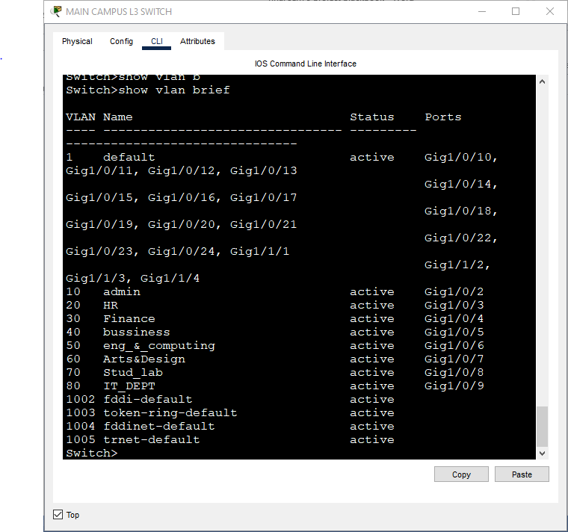

**Figure 1: VLAN Configuration Verification on Switch**

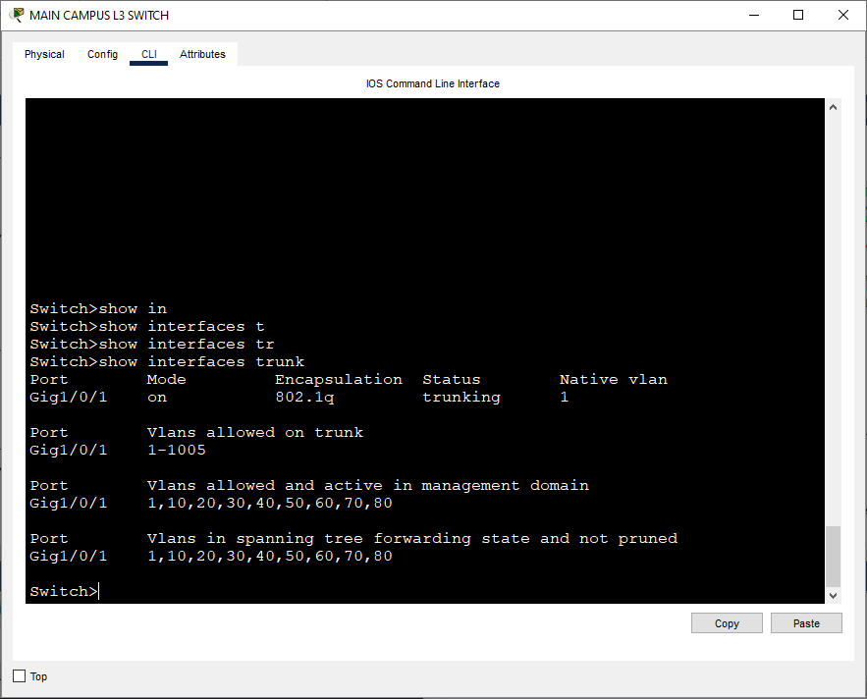

**Figure 2: Trunk Links Verification**

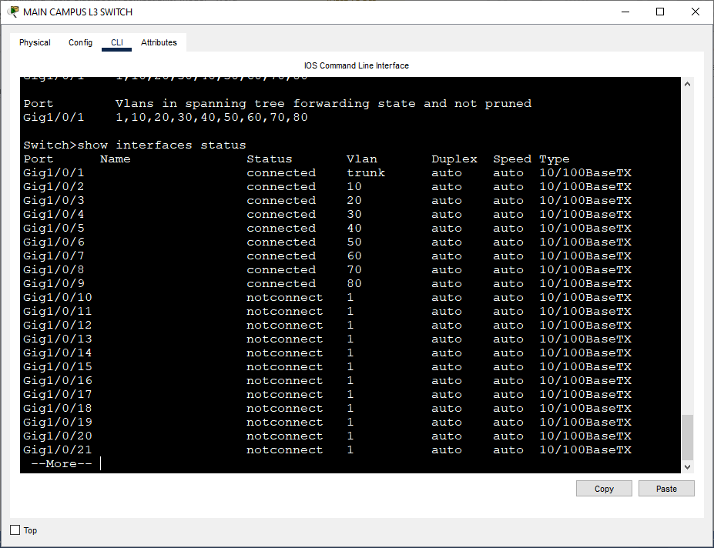

**Figure 3: Switch Interface Status**

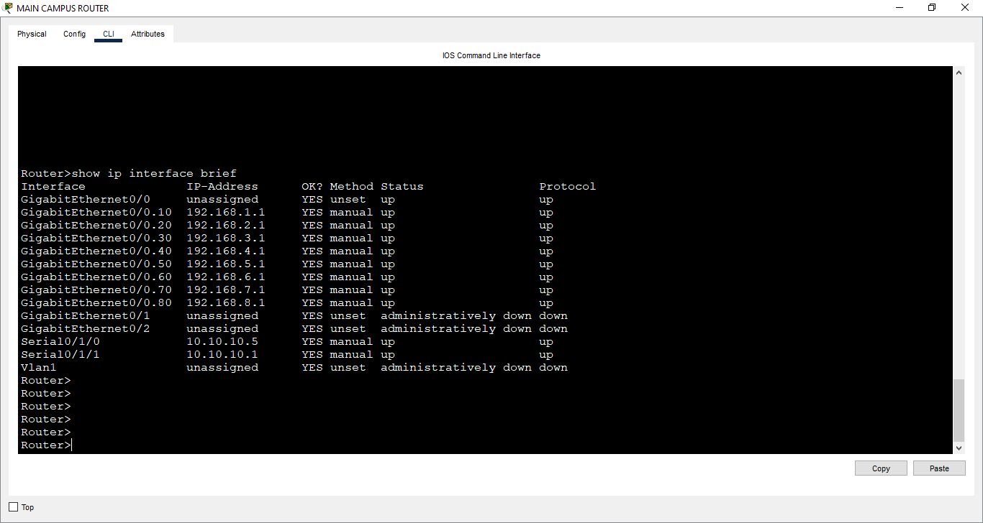

**Figure 4: Router Interface Status**

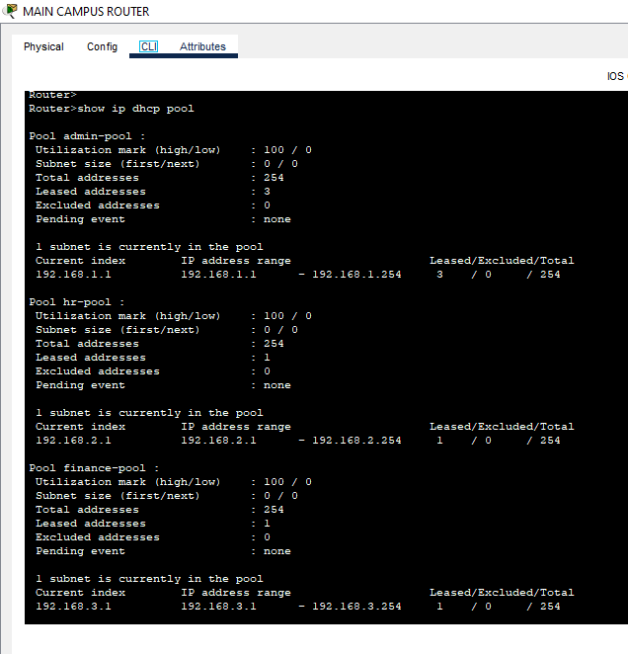

**Figure 6: DHCP Pools Verification**

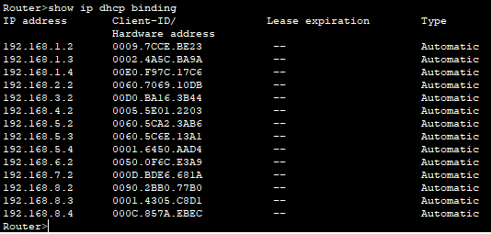

**Figure 7: DHCP Bindings Proof**

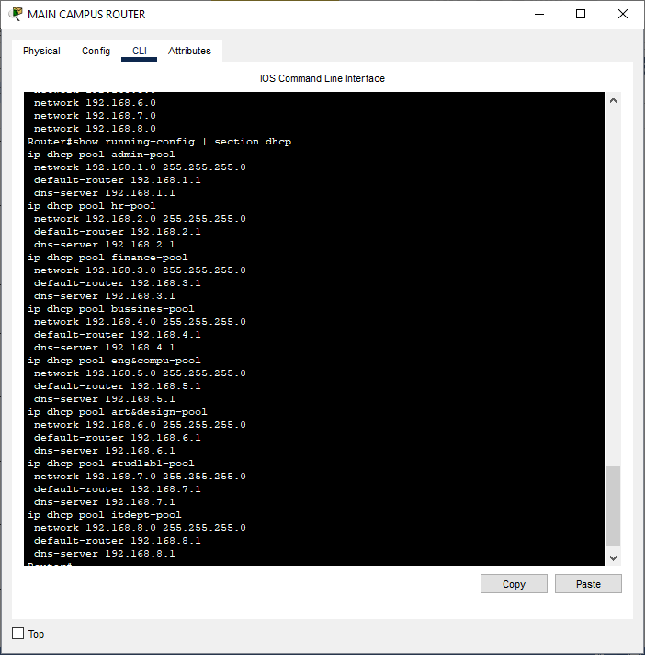

**Figure 8: DHCP Configuration Proof**

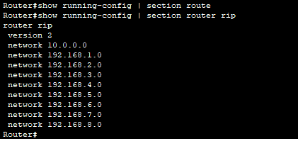

**Figure 9: RIP v2 Configuration Verification**

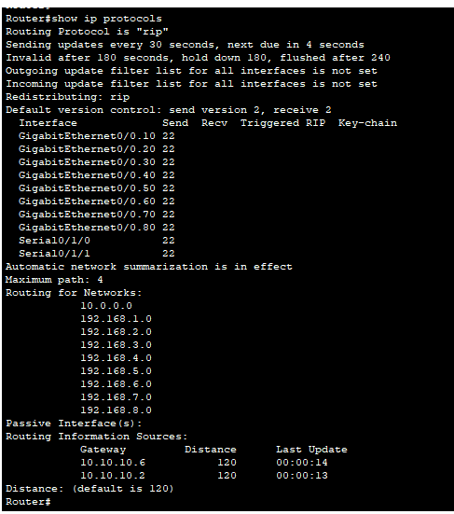

**Figure 10: RIP Protocol Details**

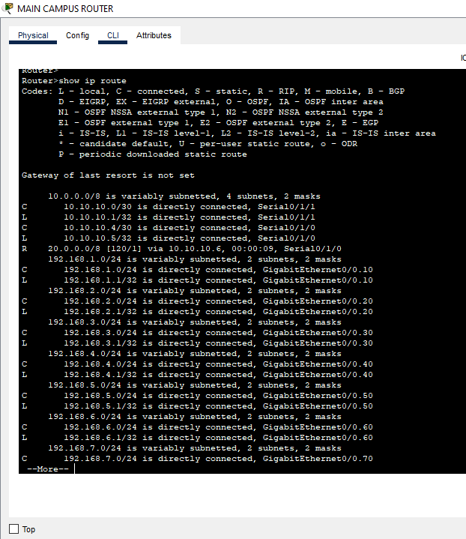

**Figure 11: Routing Table Verification**

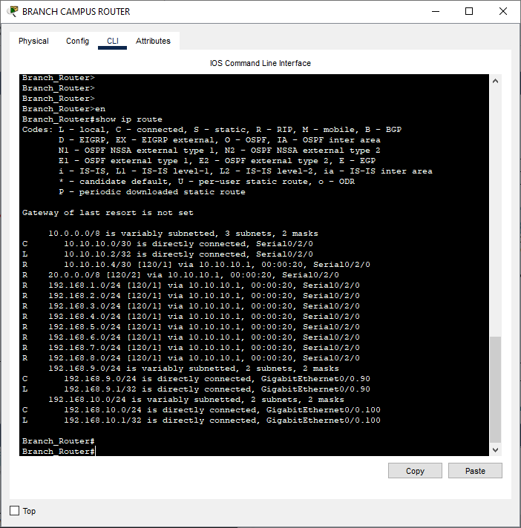

**Figure 12: Routing Table on Branch Router**

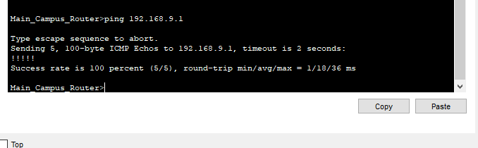

**Figure 13: Inter-Campus Connectivity Test (Ping)**

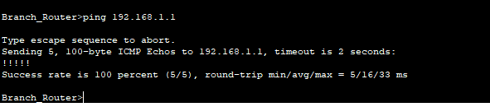

**Figure 14: Reverse Connectivity Test (Ping)**

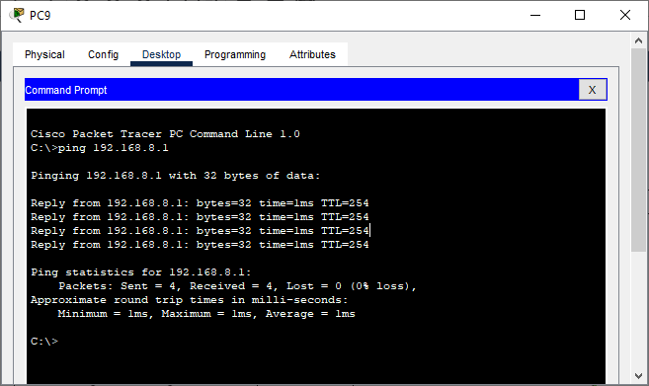

**Figure 15: End Device Gateway Ping Test**

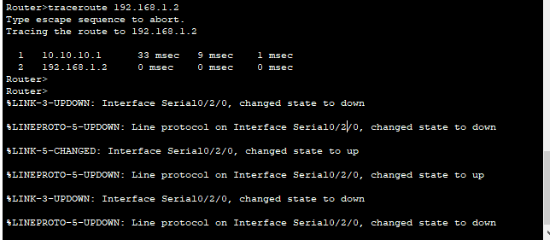

**Figure 16: Traceroute Connectivity Proof**

**9. Future Scope**

**Advanced Routing Protocols**: Replace RIP with a more advanced routing protocol like OSPF or EIGRP to improve scalability and convergence time.

**Wireless Network Integration:** Add wireless network components (access points, wireless controllers) to provide wireless access to students and staff.

**Firewall and Intrusion Detection:** Introduce firewall rules and intrusion detection systems (IDS) to enhance network security. Consider using an actual firewall appliance within Packet Tracer.

**Network Management:** Implement Simple Network Management Protocol (SNMP) for centralized network monitoring and management.

**VPN Tunnels:**Add Virtual Private Network (VPN) tunnels between campuses for secure remote access and inter-campus communication.

**Quality of Service (QoS):** Implement QoS policies to prioritize critical network traffic, such as voice and video.

**Network Automation:** Explore network automation tools and techniques to simplify network configuration and management.

**10. References:**

* Cisco Packet Tracer Documentation

* Cisco Networking Academy

* GeeksforGeeks – Networking

* NetworkLessons.com

* Classroom Notes

* RFCs for RIP v2 (Request for Comments)

**8. Conclusion**

This project successfully demonstrated the design and implementation of a large-scale university network using VLANs, DHCP, RIP v2, and static routing. The network provides secure and reliable communication between departments and campuses. The design is scalable and can be expanded to accommodate future growth. While RIP v2 was used, its limitations regarding hop count should be acknowledged and justified.